IPPIS THIRD-PARTY SETTLEMENT MANAGEMENT SYSTEM

THIRD-PARTY UNIT USER MANUAL

Version 1.0

07/02/2022

**Table of Contents**

1. Introduction 3

2. Overview 4

2.1 Conventions 4

3. Getting Started 5

3.1 Set-up Considerations 5

3.2 User Access Considerations 5

3.3 Accessing The System/ Login Page 5

3.4 Exiting The System 6

4. Using the System 8

4.1 User Dashboard Page 8

4.2 Upload Deduction 9

4.3 Deduction Files 11

4.3.1 Uploaded Deductions 12

4.3.2 Verified Files 14

5. Approve System-Verified Loans 17

## Introduction

IPPIS Third-Party Settlement Management System (IPPIS-TPSMS) is a software powered by the Workers Aggregated Credit Scheme (WACS) for the Third-Party Unit to automate the administration and management of all third-party remittances and deductions in a transparent and auditable manner in conformity with Civil Service rules. The deployment of the system will be in phases, starting with the Loan Management Module. The goal of the module is to achieve the under listed:

* To establish a single source of truth for IPPIS loan data.
* To enable IPPIS take complete ownership of all third-party deduction data.
* To create an automated platform for lenders to communicate details of new loans to IPPIS.
* To create a channel for payroll service providers to access valid third-party deductions data for payroll purposes.
* Provide comprehensive information dashboards for analysis and reports.

**The IPPIS-TPSMS Components**

The IPPIS-TPSMS Platform is an integrated system that uses smart technologyto provide an end-to-end automated solution that will eliminate all the lapses associated with the current manual processing and management of pay-day loans to Federal Government employees enrolled under IPPIS.

The system is designed to be flexible, scalable and secure. It is able to accommodate integrations with other systems, including:

* IPPIS systems in Payment, Third-Party and Payroll Units.
* Credit Processing and Administration platforms of Commercial Banks and other lenders.
* Payroll Service Providers platforms.

Interaction with external systems is provided via protocols developed in accordance with rules of information exchange; and performed via a secure HTTPS using SSL. Transmission of requests is implemented on a basis of secure web service mechanism using Application Programming Interfaces (APIs) and bearer tokens

## Overview

### 2.1 Conventions

This document provides screen prints and corresponding narrative to describe how to use the **IPPIS-Third Party Settlement Management System (IPPIS-TPSMS)**

A grey arrow like this is used to indicate fields or elements where actions are executed.

Fields or buttons to be acted upon are indicated in bold italics in the Action statement; links to be acted upon are indicated as links in underlined blue text in the Action statement.

Note: The term **‘user’** is used throughout this document to refer to a person who requires and/or has acquired access to the **IPPIS**-**TPSMS**.

## Getting Started

The IPPIS-TPSMS platform uses an authorized user account e-mail address as the login username and requires a unique Password to access the system.

### 3.1 Set-up Considerations

TheIPPIS-TPSMS screen is very responsive and can be accessed conveniently on large desktop and laptop screens.

To optimize your access to the IPPIS-TPSMS:

1. Please disable pop-up blockers prior to attempting access to the IPPIS-TPSMS portal.
2. Use Internet Explorer, version 6.0 or higher.
3. Use Android or iOS devices to access on mobile phones.

### 3.2 User Access Considerations

This user manual is developed for IPPIS Third-Party Unit users of the IPPIS-TPSMS.

### 3.3 Accessing The System/ Login Page

The IPPIS-TPSMS portal can be accessed using the following URL: <https://thirdparty.ippis.gov.ng/ippis>. Users input their user account email as Username and a unique password to log into the portal.

Each authorized user must have a user account to access the portal.

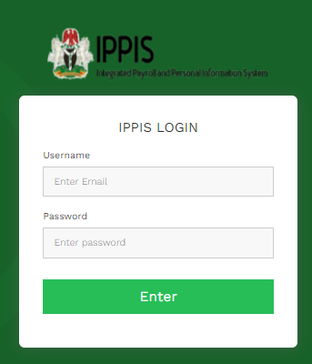

**1**

**2**

The elements in the login page are as listed below:

1. ***Email or Username Field:***

This is where the user enters user account email address.

1. ***Password Field:***

This is where the user enters the unique password for login access.

### 3.4 Exiting The System

To exit the **IPPIS-TPSMS** Portal**,** access the option from the one of the self-service options available to the user.

**1**

**2**

**Actions:**

1. Click on the User Name displayed at the top right corner of the screen to drop down a menu of options.
2. Select the option *Log Out* to log out from and to exit the platform.

## 4. Using the System

The following sub-sections provide detailed, step-by-step instructions on how to use the various functions or features of the **IPPIS-TPSMS**.

### 4.1 User Dashboard Page

Every successful login into the system displays the Dashboard page which gives overview and analytics of new loans approved by lenders (after the upload of running loans) and thereafter uploaded on the IPPIS-TPSMS platform to update IPPIS record through Third Party Unit.

The views and actions that can be performed on the Dashboard are:

**3**

**2**

**1**

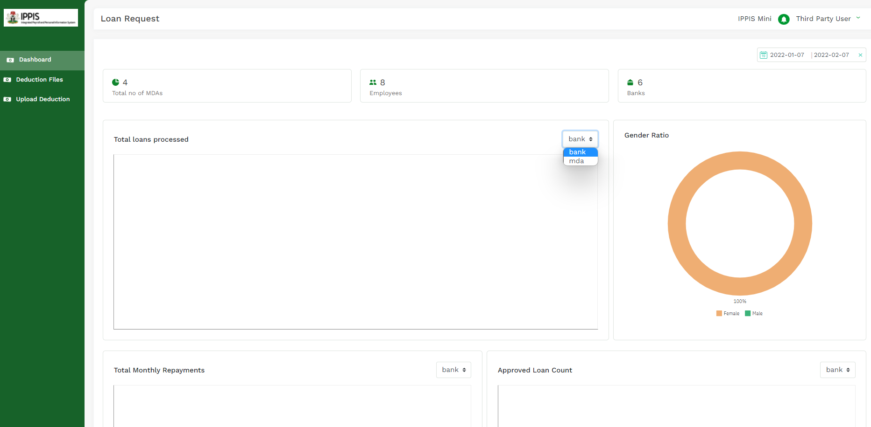

**5a**

**6**

**5b**

**4**

**8b**

**7b**

**8a**

**7a**

1. **Date Filter** to specify the exact or range of period of the required dashboard view.
2. **View of Number of MDAs** where employees have accessed new loans**.**
3. **View of Number of Employees** that lenders have approved new loans for**.**
4. **View of Number of Banks** that have approved new loans in favour of employees.
5. **Total Loans Processed** within the period specified in the date filter (No. 1 above). The view displayed is determined by clicking on the drop-down box to display and select the dashboard view filter of either Bank or MDA **(5b).**
6. **Gender Ratio** of new loan beneficiarieswithin the period specified in the date filter (No. 1 above).
7. **Total Loan Repayments** within the period specified in the date filter (No. 1 above). The view displayed is determined by clicking on the drop-down box to display and select the dashboard view filter of either Bank or MDA **(7b).**
8. **Approved Loan Count** within the period specified using in the date filter (No. 1 above). The view displayed is determined by clicking on the drop-down box to display and select the dashboard view filter of either Bank or MDA **(8b).**

### 4.2 Upload Deduction

Click on the Upload Deduction tab on the list of options in the Menu list on the left side of the home/dashboard page.

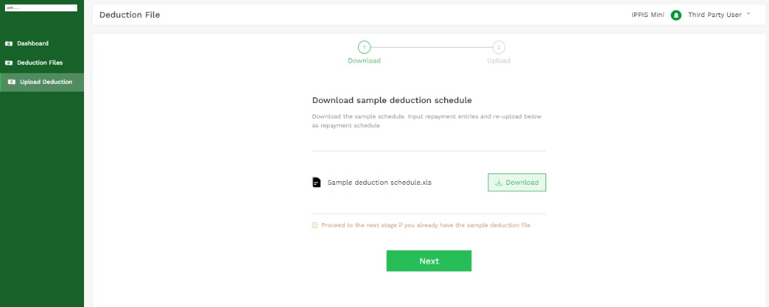

The following actions can be performed on the Download Tab of the Upload Deduction menu:



**2**

**1**

1. Click on the Download button to download a sample deduction schedule. This is to ensure the headers in the deduction schedule to be uploaded are compatible with IPPIS-TPSMS format.
2. Click on the Next button after successfully downloading the sample deduction schedule or to skip the step for downloading the deduction schedule to proceed to the page for uploading a new deduction sheet.

The following actions can be performed on the Upload Tab of the Upload Deduction menu to upload a new deduction file:

**1**

**2**

**3**

1. Click on the drop-down button in the Select Payment Type field to display and select the repayment type (Salary or Bank Loan) the deduction schedule was prepared for.
2. Click on the drop-down button in the Select Bank field to display and select the lender whose deduction schedule is being uploaded.
3. Upload the deduction file by selecting from a saved location on the computer or dragging and dropping in the upload field.

### 4.3 Deduction Files

This page provides a view of uploaded deductions and can be accessed by clicking on the Deduction Files tab in the Menu list. The two views available here are:

**1**

**2**

1. Uploaded Deductions
2. Verified Files

### 4.3.1 Uploaded Deductions

Select the Uploaded Deductions tab to view uploaded batches and details of records uploaded.

The following actions can be performed here:

**1**

**2**

**3**

1. Click on the drop-down button in the Select Payment Type field to display and select the repayment type (Salary or Bank Loan) of the uploaded deduction schedule. Select Bank Loan.
2. Click on the Fetch Batches button to fetch all previously uploaded deduction schedules.
3. The details of all fetched batches are displayed in a list with the following headers: Batch Name, Date, Company Name, Total Records, Records Validated, Total Amount, Maker and Status.

To view all the details of the records in a batch, select the desired batch

The following details of all the records selected batch are automatically displayed: Ref ID, IPPIS Number, Employee Name, Start Date, End Date, Loan Collected, Balance, Amount Paid, Repayment Amount, confirmation of consistency and confirmation of validation.

The IPPIS-TPSMS is configured to configured to automatically run regular scheduled algorithms to validate the records on the deduction files uploaded by lenders against the records uploaded by IPPIS. The criterion for validation is the consistency of all fields in an employee’s record with both the Third-Party Unit and the lender.

Records that are validated are automatically transmitted into the Verified Files portal of the IPPIS-TPSMS.

### 4.3.2 Verified Files

Select the Verified Files tab to view records of verified loans.

The following actions can be performed here:

**1**

**2**

**3**

1. Click on the drop-down button in the Select Payment Type field to display and select the repayment type (Salary or Bank Loan) of the uploaded deduction schedule.
2. Click on the Fetch Batches button to fetch batches of verified files.
3. The details of all fetched batches are displayed in a list with the following headers: Batch Name, Date, Company Name, Total Records, Records Validated, Total Amount, Maker and Status.

To view all the details of verified records in a batch, select the desired batch

The following details of all the verified files are automatically displayed: Ref ID, IPPIS Number, Employee Name, Start Date, End Date, Loan Collected, Balance, Amount Paid, Repayment Amount, confirmation of consistency and confirmation of validation.

## 5. Approve System-Verified Loans

Following system-prompts, IPPIS-TPSMS Admin Users login to the system to view and verify all system-verified loans to complete the loan validation process.